Korak 5 — Realtime Analytics + AI Anomaly Detection + Predictive Maintenance
Sada već imaš pravi IoT/SCADA stack:
- CrateDB
- EMQX
- Locust
- Vue.js
- Quasar Framework
Sada dodajemo:
- realtime analytics
- anomaly detection
- predictive maintenance
- health score trafostanice
- AI alarm scoring
Ovo već postaje pravi Smart Grid / Digital Twin sustav.

Što ćemo analizirati
Iz podataka koje već imamo:

Elektrika
- napon
- struja
- harmonici
- snaga

Termalno
- temperatura ulja
- temperatura namota

Ulje/plinovi
- vodik
- metan
- acetilen
- vlaga

Cilj AI layera
Detektirati:
- overheating
- overload
- degradaciju izolacije
- lošu kvalitetu energije
- rizik kvara transformatora
- abnormalne trendove

Nova arhitektura
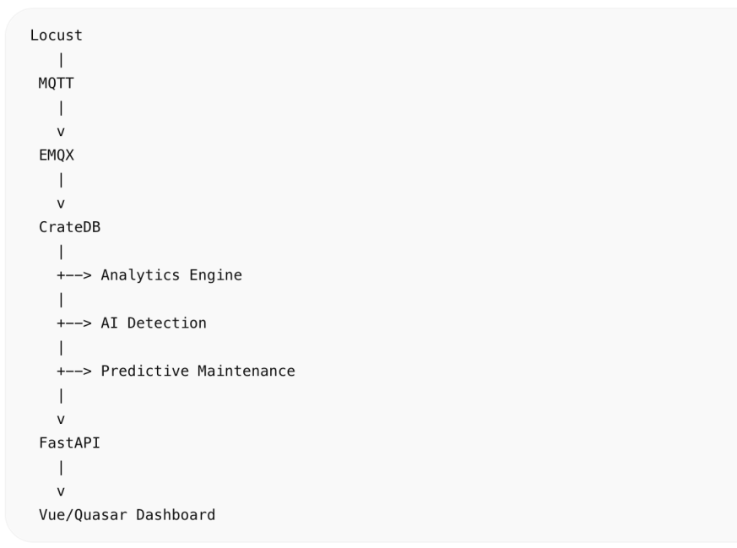

1. CrateDB realtime analytics

Average load
SELECT  station_id,  AVG(electrical['current_a']) AS avg_current,  AVG(thermal['oil_temp_c']) AS avg_temp,  AVG(electrical['harmonics_thd']) AS avg_thd  FROM trafostanice_sensors  GROUP BY station_id; | 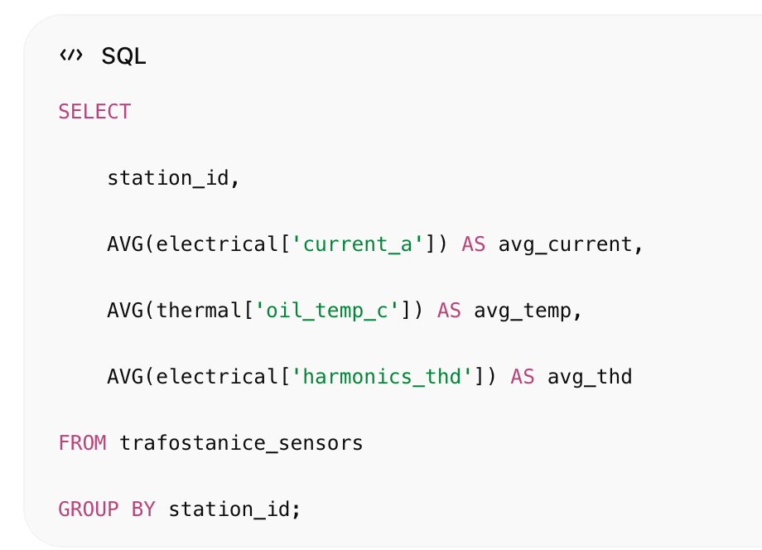

2. Health score
Računamo health score:
- 100 = zdravo
- 0 = kritično

SQL health formula
SELECT  station_id,  100  - AVG(thermal['oil_temp_c']) * 0.4  - AVG(electrical['harmonics_thd']) * 5  - AVG(oil_gas['hydrogen_ppm']) * 0.8  AS health_score  FROM trafostanice_sensors  GROUP BY station_id  ORDER BY health_score ASC; | 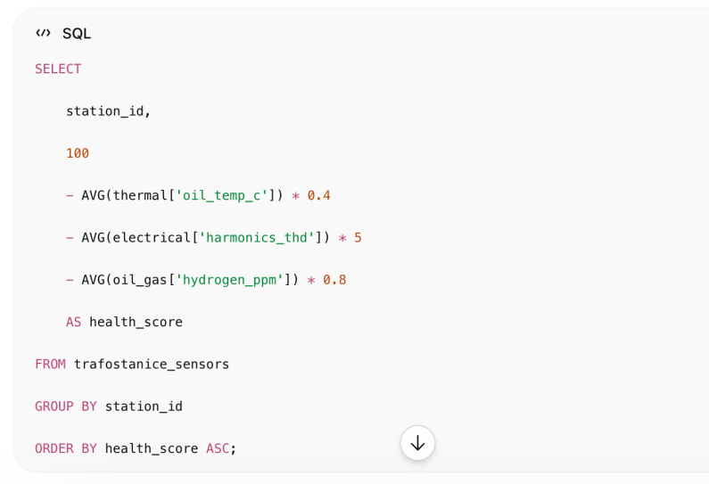

3. Anomaly detection
Detektiramo:
- previsoku temperaturu
- abnormalne harmonike
- nagli skok struje
- DGA abnormalnosti

SQL anomaly query
SELECT *  FROM trafostanice_sensors  WHERE  thermal['oil_temp_c'] > 90  OR electrical['harmonics_thd'] > 4.5  OR oil_gas['hydrogen_ppm'] > 15  OR electrical['current_a'] > 600; | 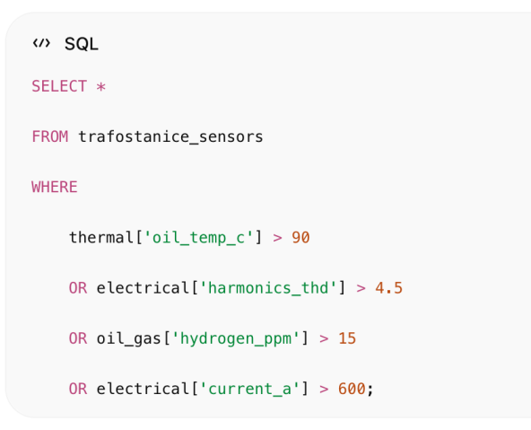

4. Predictive maintenance
Ideja:
- gledamo trend temperature
- trend plinova
- trend opterećenja
- degradaciju kroz vrijeme

Failure risk score
SELECT  station_id,  AVG(thermal['oil_temp_c']) * 0.35  +  AVG(oil_gas['hydrogen_ppm']) * 1.5  +  AVG(electrical['harmonics_thd']) * 4  +  AVG(electrical['current_a']) * 0.05  AS failure_risk  FROM trafostanice_sensors  GROUP BY station_id  ORDER BY failure_risk DESC; | 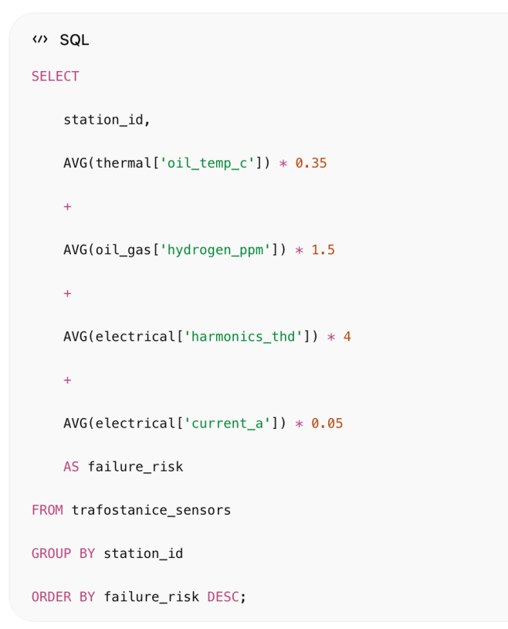

5. AI analytics service
Dodaj novi servis:
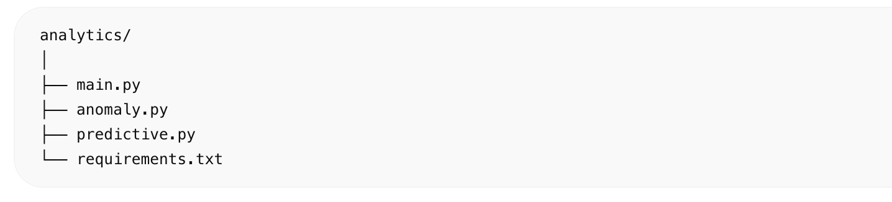

requirements.txt
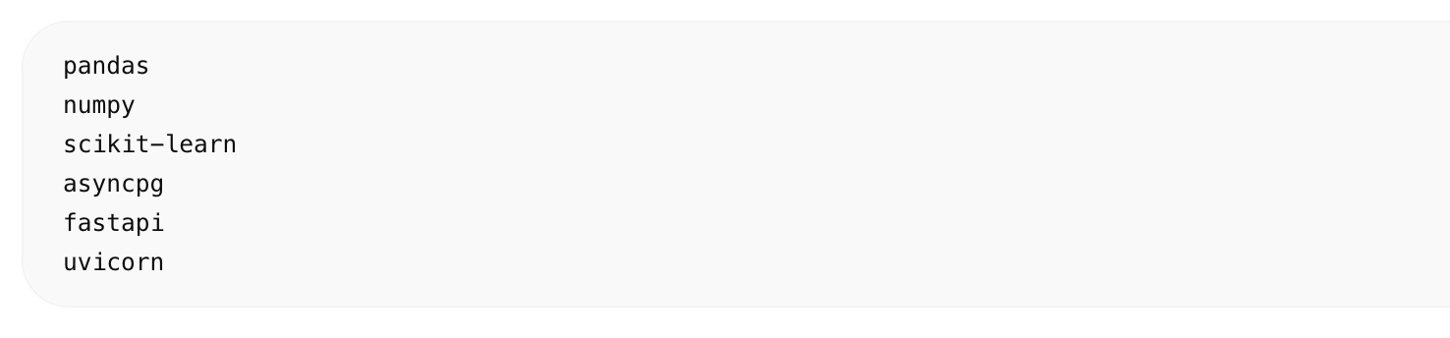pandas
numpy
scikit-learn
asyncpg
fastapi
uvicorn

anomaly.py
Koristimo Isolation Forest.
from sklearn.ensemble import IsolationForest  import pandas as pd  def detect_anomalies(df):  features = [  'current_a',  'oil_temp_c',  'harmonics_thd',  'hydrogen_ppm'  ]  model = IsolationForest(  contamination=0.02,  random_state=42  )  df['anomaly'] = model.fit_predict(  df[features]  )  return df | 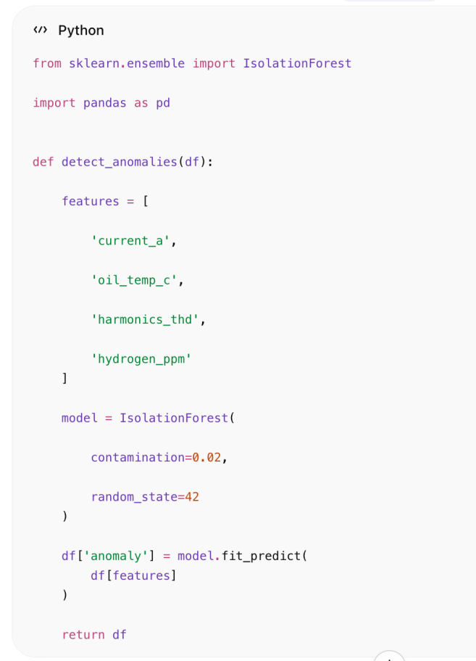
predictive.py
Simple predictive maintenance score.
def calculate_health(row):  score = 100  score -= row['oil_temp_c'] * 0.4  score -= row['harmonics_thd'] * 5  score -= row['hydrogen_ppm'] * 1.2  score -= row['current_a'] * 0.03  return max(score, 0) | 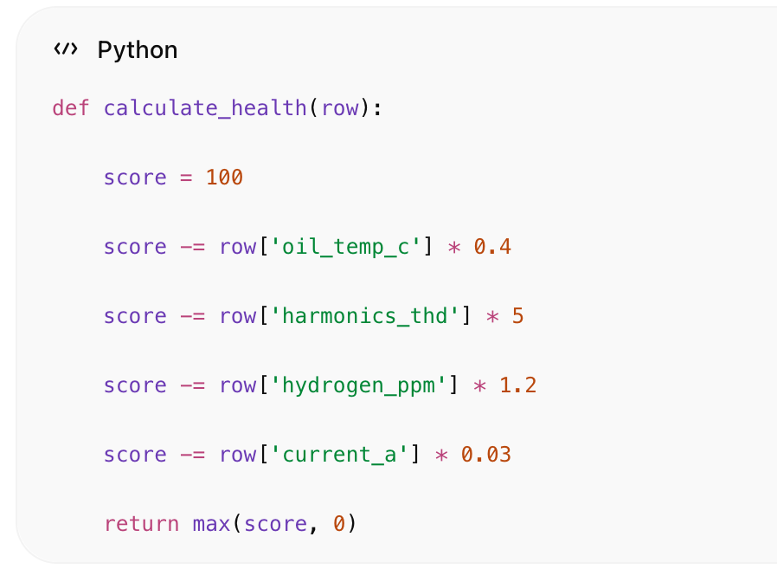

6. Analytics API

main.py
from fastapi import FastAPI  app = FastAPI()  @app.get("/analytics/health")  async def health_scores():  return {  "critical": 23,  "warning": 88,  "healthy": 889  }  @app.get("/analytics/anomalies")  async def anomalies():  return [  {  "station_id": "TS-0442",  "risk": "critical",  "reason": "high oil temp"  }  ] | 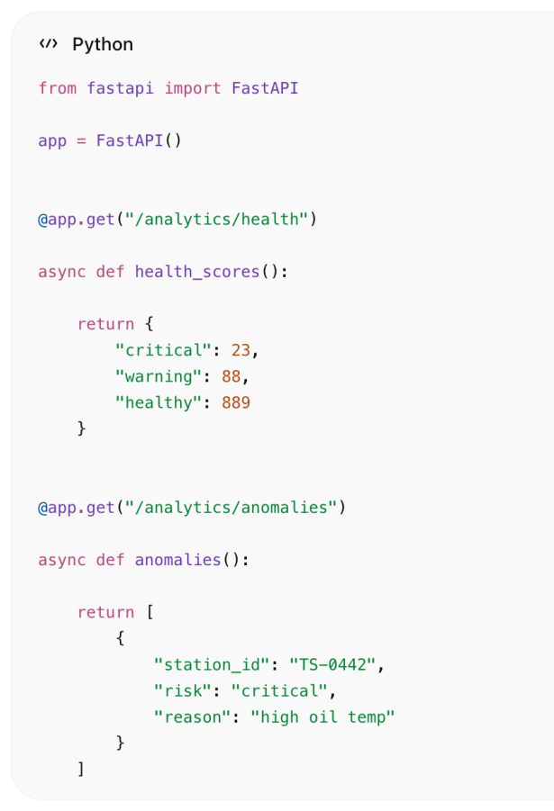

7. Dashboard Analytics Panel
Dodaj:
- health score
- risk ranking
- anomaly alerts
- transformer ranking

Quasar Analytics Card
<template>  <q-card  dark  class="bg-orange"  >  <q-card-section>  <div class="text-h6">  AI Analytics  </div>  <div>  Critical:  {{ analytics.critical }}  </div>  <div>  Warning:  {{ analytics.warning }}  </div>  <div>  Healthy:  {{ analytics.healthy }}  </div>  </q-card-section>  </q-card>  </template> | 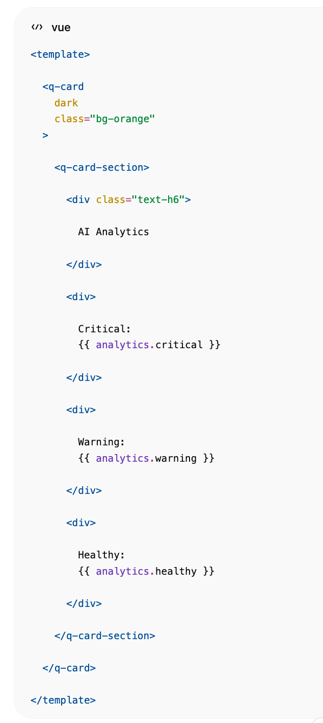

8. Smart SCADA Features
Sada možeš:
- rangirati trafostanice
- predvidjeti kvarove
- otkriti abnormalnosti
- pratiti health score
- vidjeti toplinsku degradaciju
- detektirati lošu izolaciju

9. Realtime Heatmap
CrateDB GEO_POINT + Leaflet:
- heatmap temperature
- overload zones
- harmonics density
- outage clustering

10. Napredna AI ideja
Kasnije možeš dodati:
- LSTM forecasting
- Transformer models
- Graph Neural Networks
- Digital Twin
- Grid balancing AI
- Power demand prediction

Što sada imaš
Praktički:
- IoT platformu
- Smart Grid simulator
- SCADA dashboard
- realtime analytics
- AI anomaly detection
- predictive maintenance
- geo analytics
- realtime streaming
- distributed TSDB

Sljedeći korak
Možemo sada dodati:

7. AI forecasting
- load prediction
- blackout prediction
- transformer lifetime prediction
- 1 Arhitektura AI forecasting sloja
ad dodajemo forecasting sloj koji radi na povijesnim podacima iz CrateDB i daje predikcije:
- load prediction (opterećenje)
- blackout prediction (rizik nestanka)
- transformer lifetime prediction (preostali životni vijek)
Koristit ćemo:
- CrateDB (data source + agregacije)
- scikit-learn (baseline ML)
- (kasnije možeš dodati PyTorch / LSTM ako želiš upgrade)

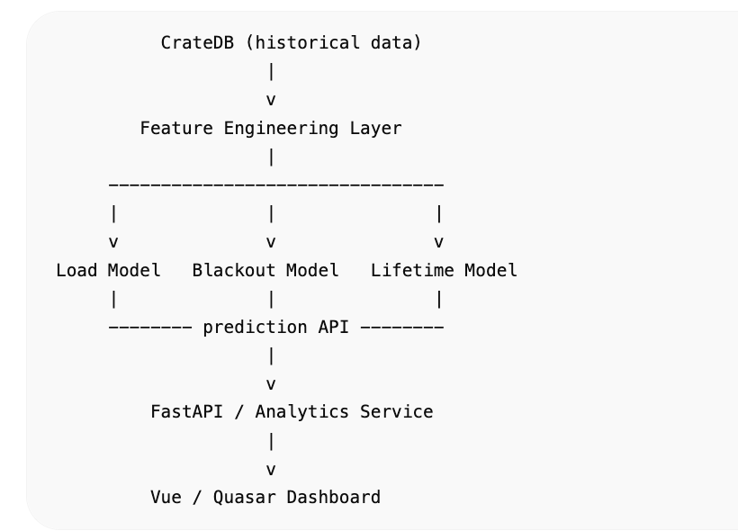
7. 2 Feature set (što model gleda)
Iz tvoje simulacije (Locust + EMQX):

Input features

Elektrika
- current_a
- voltage_kv
- active_power_kw
- harmonics_thd

Termalno
- oil_temp_c
- winding_temp_c

Ulje / plinovi
- hydrogen_ppm
- methane_ppm
- acetylene_ppm

Derived features
- load_factor
- temp_gradient
- gas_growth_rate (trend)
volatility (std dev)
7.3 Feature engineering (Python)
import pandas as pd  import numpy as np  def build_features(df):  df = df.sort_values("timestamp")  df["load_factor"] = df["current_a"] / 500 # nominal  df["temp_diff"] = df["oil_temp_c"] - df["ambient_temp_c"]  df["gas_index"] = (  df["hydrogen_ppm"] +  df["methane_ppm"] * 2 +  df["acetylene_ppm"] * 5  )  df["rolling_temp"] = df["oil_temp_c"].rolling(10).mean()  df["rolling_load"] = df["current_a"].rolling(10).mean()  return df.dropna() | 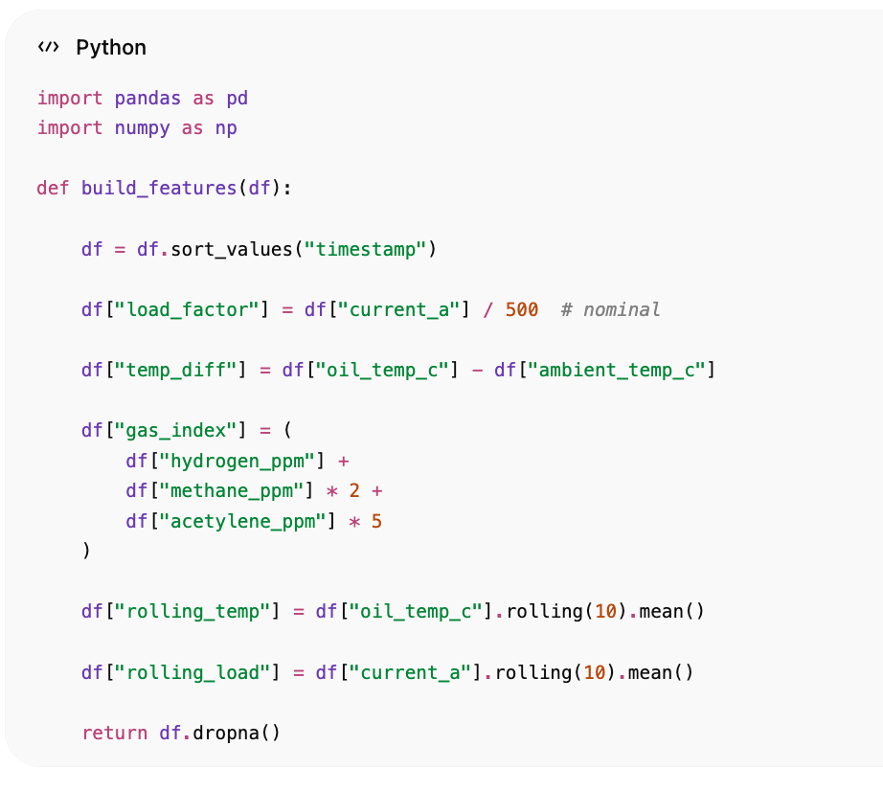

7.4 LOAD PREDICTION (opterećenje)

Model ideja
- predviđamo budući current_a (15–60 min ahead)

Model (baseline)
from sklearn.ensemble import RandomForestRegressor  features = [  "voltage_kv",  "active_power_kw",  "harmonics_thd",  "rolling_load"  ]  target = "current_a"  model = RandomForestRegressor(  n_estimators=200,  random_state=42  ) | 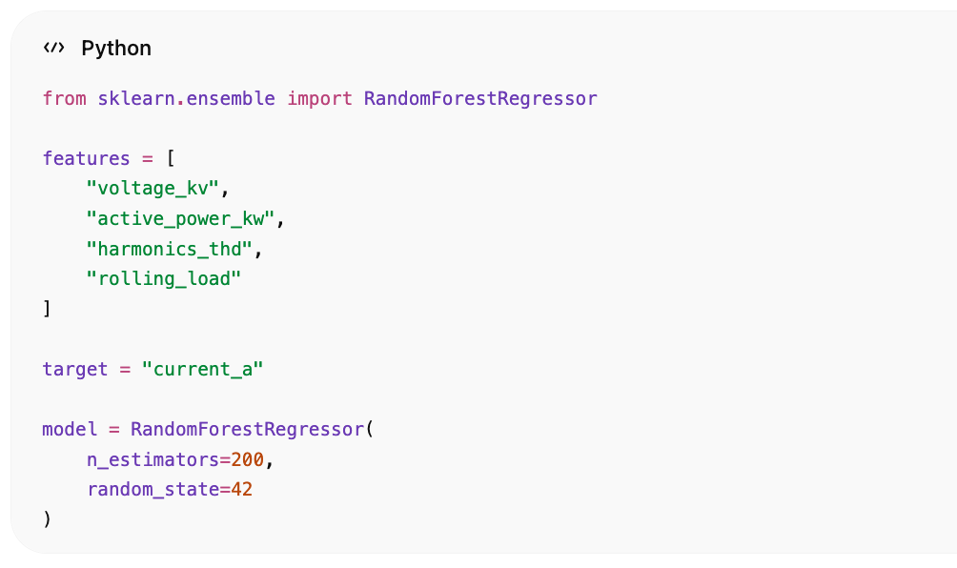

Train
def train_load_model(df):  X = df[features]  y = df[target]  model.fit(X, y)  return model | 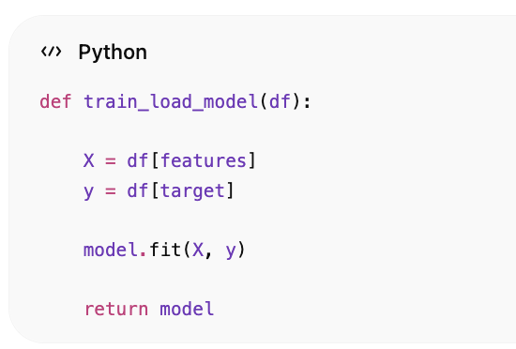

Prediction
def predict_load(model, latest_row):  return model.predict([latest_row])[0] | 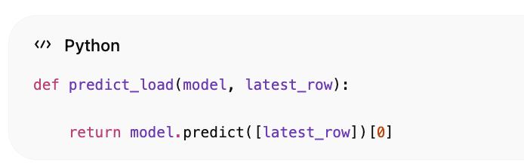

8. BLACKOUT PREDICTION (RIZIK ISPADA)
Ovo je classification problem:
- 0 = normal
- 1 = blackout risk

Label definition (heuristika)
def create_blackout_label(df):  df["blackout_risk"] = (  (df["voltage_kv"] < 9.5) |  (df["current_a"] > 650) |  (df["oil_temp_c"] > 95) |  (df["harmonics_thd"] > 5)  ).astype(int)  return df | 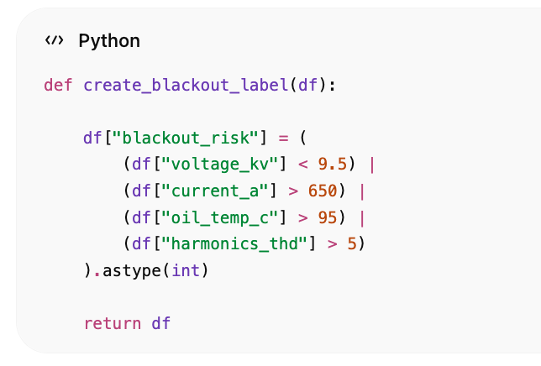

Model
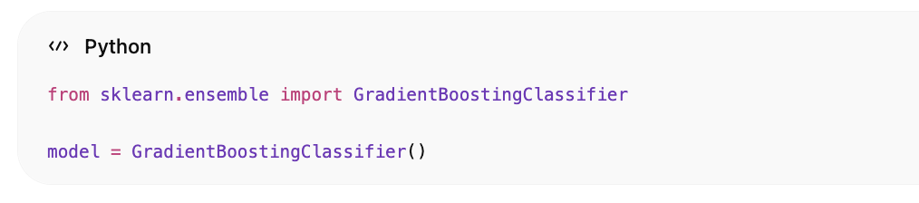
from sklearn.ensemble import GradientBoostingClassifier
model = GradientBoostingClassifier()

Train
features = [  "current_a",  "voltage_kv",  "oil_temp_c",  "harmonics_thd",  "gas_index"  ]  def train_blackout_model(df):  X = df[features]  y = df["blackout_risk"]  model.fit(X, y)  return model | 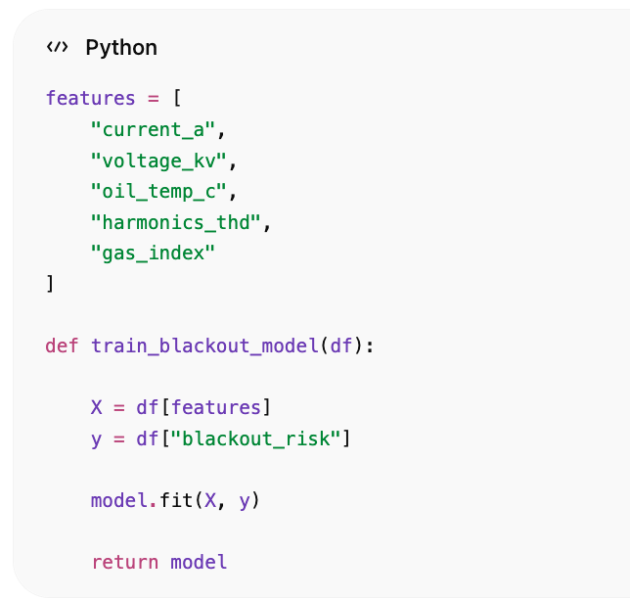

Output
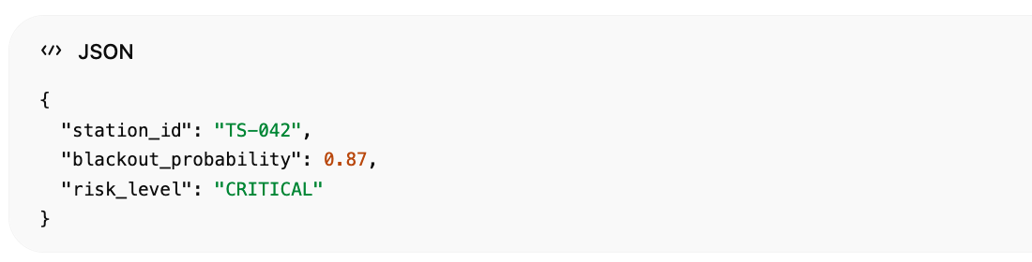{
"station_id": "TS-042",
"blackout_probability": 0.87,
"risk_level": "CRITICAL"
}

9.TRANSFORMER LIFETIME PREDICTION
Ovo je regression problem:
- output = remaining life (days)

Idea
Degradacija ovisi o:
- temperaturi
- plinovima
- overloadu
- harmonics

Health degradation formula (baseline AI)
def estimate_lifetime(df):  base_life = 25 * 365 # 25 years  degradation = (  df["oil_temp_c"].mean() * 2.5 +  df["hydrogen_ppm"].mean() * 10 +  df["harmonics_thd"].mean() * 50 +  (df["current_a"].mean() / 10)  )  remaining_life = base_life - degradation * 30  return max(remaining_life, 0) | 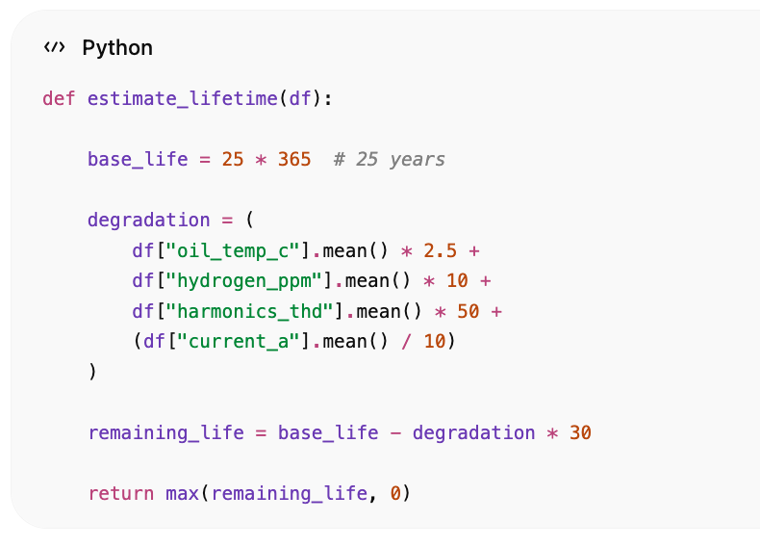

ML verzija (bolje)
from sklearn.ensemble import RandomForestRegressor  model = RandomForestRegressor(n_estimators=300)  features = [  "oil_temp_c",  "winding_temp_c",  "hydrogen_ppm",  "harmonics_thd",  "current_a"  ]  target = "remaining_life_days" | 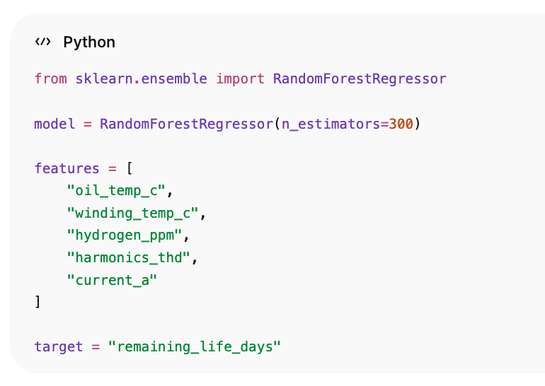

10. AI FORECASTING SERVICE (FastAPI)
from fastapi import FastAPI  app = FastAPI()  @app.get("/ai/load/{station_id}")  def load_prediction(station_id):  return {  "station_id": station_id,  "predicted_load_a": 420  }  @app.get("/ai/blackout/{station_id}")  def blackout_risk(station_id):  return {  "station_id": station_id,  "probability": 0.78,  "risk": "HIGH"  }  @app.get("/ai/lifetime/{station_id}")  def lifetime(station_id):  return {  "station_id": station_id,  "remaining_life_days": 4200  } | 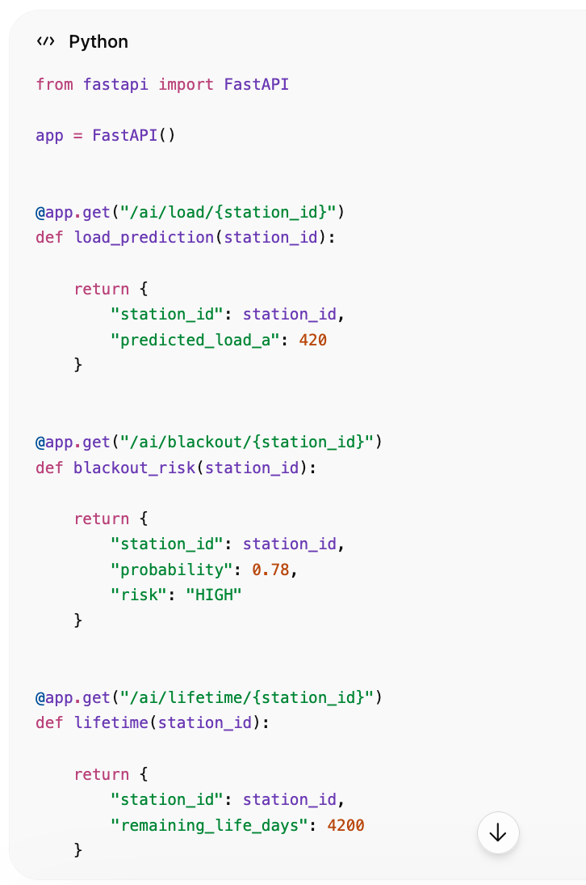

11.CrateDB real-time agregacije (ključna stvar)

Load trend
SELECT  station_id,  DATE_TRUNC('minute', timestamp) AS t,  AVG(current_a) AS avg_load  FROM trafostanice_sensors  GROUP BY station_id, t  ORDER BY t DESC; | 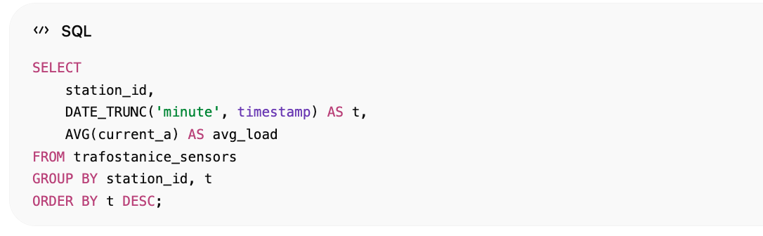

Gas degradation trend
SELECT  station_id,  AVG(hydrogen_ppm) AS h2,  AVG(methane_ppm) AS ch4  FROM trafostanice_sensors  GROUP BY station_id; | 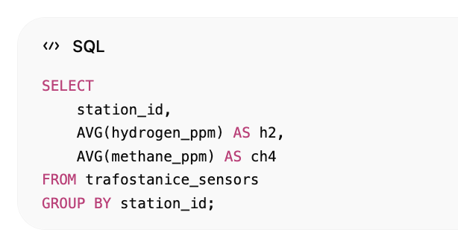

12. Vue/Quasar AI dashboard panel

AI Card
<template>  <q-card dark class="bg-purple">  <q-card-section>  <div class="text-h6">  AI Forecast  </div>  <div>Load: {{ load }} A</div>  <div>️ Blackout risk: {{ risk }}%</div>  <div> Lifetime: {{ life }} days</div>  </q-card-section>  </q-card>  </template>  <script setup>  defineProps({  load: Number,  risk: Number,  life: Number  })  </script> | 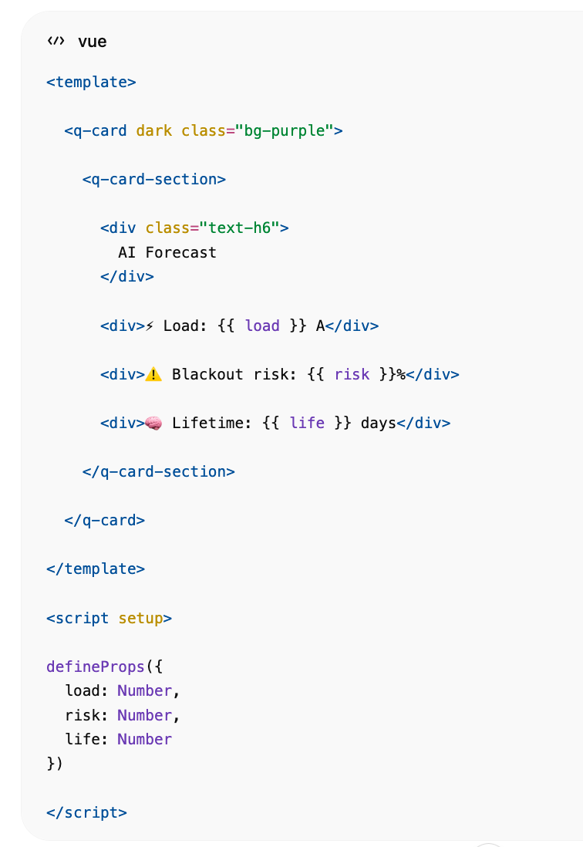
Sada imaš:

Load prediction
- buduće opterećenje mreže

Blackout prediction
- rizik ispada trafostanice
- early warning system

Transformer lifetime
- preostali životni vijek
- asset management

Što si zapravo dobio
Ovo više nije simulator, ovo je Digital Twin Smart Grid sustav sa:
- realtime IoT streaming
- SCADA dashboard
- geo mrežom trafostanica
- AI anomaly detection
- AI forecasting
- predictive maintenance
- asset lifetime modeling

